Subcontracting Policy

Policy Reference | COG-SC01082023
Issue Date | August 2023
Review Date | August 2024
Owner | Nick Durrington
Audience | Eligible subcontractors only
Confidentiality | Public Access

Purpose
In accordance with the ESFA Subcontracting Standard, ESFA policy and funding rules this document sets out the rationale and defines the arrangements under which Cogent Skills will subcontract ESFA funded apprenticeship provision. It identifies the core principles that Cogent Skills will take into consideration prior to entering into a legally binding contract with an apprenticeship delivery subcontractor.

Rationale
Cogent Skills has a commitment to deliver excellence for apprentices and the employer, meeting organisational needs and generating opportunities for employees to develop, achieve and progress.
In normal circumstances, Cogent Skills will plan and validate our apprenticeship programmes with the intention of delivering all parts of the programme without the use of subcontractors. Cogent Skills will only agree to subcontract delivery of any part of an apprenticeship in the following circumstances:
- Where it enhances the opportunities available for learners;
- Where it fills gaps in niche or expert provision or provides better access to training facilities;
- Where it supports better geographical access for learners
- Where it offers an entry point for disadvantaged groups; or
- Where it gives consideration of the impact on individuals with shared protected characteristics, where there might otherwise be gaps.
In these cases, the decision to subcontract will be discussed with the employer before entering into a subcontract arrangement, and will be recorded in the Subcontracting Agreement for services with the employer.
Where any element of the programme is subcontracted to the employer or another provider, they must either be a Lead or Supporting Provider on ESFA’s Register of Apprenticeship Training Providers (RoATP) or a register Employer Provider.
As the Lead Provider Cogent Skills will:
- Agree the use of subcontractors with employers at the start of an apprenticeship.
- Carry out due diligence checks on potential delivery subcontractors.
- Enter into a written Subcontracting Agreement with subcontractors.
- Ensure that second-level subcontracting does not take place.
- Obtain an annual report from an external auditor if the total apprenticeship contract value exceeds £100,000 in any one financial year.
- Directly deliver part of the apprenticeship programme that is of substance.
- Maintain the relationship with the employer.
- Take full responsibility for the quality of all aspects of delivery and carry out regular quality assurance checks of the subcontractor’s provision.
- Provide delivery subcontractor declarations in line with ESFA dates, and manage updates if arrangements or circumstances change during the year.

Due Diligence
Cogent Skills will undertake robust due diligence when selecting potential subcontractors who are registered on the Register of Apprenticeship Training Providers (RoATP) to deliver services to employers.
Cogent Skills will conduct an annual review of its due diligence checks on each subcontract to ensure that the subcontracted provider continues to be able to deliver the contracted services.
Cogent Skills will also conduct further due diligence checks if there is any material change in the subcontracted provider that has the potential to impact on its ability to deliver subcontracted services.

Contracting Arrangements
Successful partners will be issued with a legally binding contract (Subcontracting Agreement) eligible for the period from when the contract commences until the planned completion date of an apprenticeship. It will be signed and witness by the subcontractor and Cogent Skills. Terms and Conditions will be included in the contract. Cogent Skills, Ofsted and the ESFA are granted full permission and rights to monitor the quality of training provided and visit the subcontractor at their premises and/or training sites.

Quality Assurance
Cogent Skills is committed to delivering high quality teaching, learning and assessment for the apprentice and employer across its provision and will work with the subcontractor to review progress and manage the quality of external provision.
All new subcontractors will be subject to an initial visit to confirm approval of appointment as a subcontractor.
The following processes will be used to monitor the quality of subcontracted provision and actively improve quality on an ongoing basis:
- A regularly maintain contract management plan that outlines all the quality indicators the sub-contractor must adhere to during the period of delivery
- Regular contract review meetings between Cogent Skills and the subcontractor;
- Monthly tutor and / or assessor catch-up meetings
- Termly planned and/or unplanned observation visits to check on the quality of teaching, learning, assessment and progress.
Cogent Skills will take a risk management approach to subcontractor management to ensure that appropriate levels of contact monitoring and Quality Assurance are maintained. The intervals between visits, observations and other means of assessing quality & compliance, will vary as to the associated risk associated with each subcontractor.
In order to make more effective use of Quality Assurance visits, the subcontractor will be asked to provide the following information as a minimum prior to any planned visit:
- Lesson plans / schemes of work for the lessons to be observed.
- Materials.
- Examples of learner’s work.
- Marking criteria.
- Progress notes.
- Reasonable adjustments
- Initial assessment
Where a subcontractor permanently changes delivery staff on a programme, they should inform Cogent Skills of this change immediately and send a copy of the new trainer’s CV to Cogent Skills.
All subcontractors must agree to the termly review meetings and planned/unplanned observations visits prior to being awarded contracts.
Cogent Skills will take into account feedback, both solicited and unsolicited, from apprentices in its quality assurance of a subcontractor.

Learning Support
Effective, maintained learning support is critical to the wellbeing and achievement of apprentices. All apprentices will receive IAG and learning support assessments ( to ensure that any support needs or additional requirements are identified and communicated.
Subcontractors will receive full learner-level data pertaining to identified support needs and must commit to ensuring:
- Identified learning support needs are met and maintained, with any reasonable adjustments accommodated and approved (if required) with awarding bodies.
- Emerging or newly observed learning support needs or adjustments are promptly communicated to Cogent Skills.
Cogent Skills will take into account feedback on eligible support standards, both solicited and unsolicited, from apprentices and employers in its quality assurance of a subcontractor.

Subcontractor Policies
Subcontractors are required to have robust internal policies to ensure compliance with legislative undertakings and general good practice, and are required to make certain that policies are regularly updated and effectively implemented.
As a minimum any subcontractor will be expected to have a policy or policies covering the following topics approved at an appropriate level in the organisation, copies of which will be held by Cogent Skills for audit and inspection purposes and made available to ESFA and Ofsted as part of their inspection and Audit regime:
- Health and Safety inc. Risk Assessments.
- Safeguarding/Modern Slavery/Mental Health.
- Prevent/Radicalisation.
- Data Protection/GDPR.
- Equal Opportunities/Equality and Diversity.
- Sustainability/Environmental.
- Quality Assurance/Assessment/Malpractice/Appeals.
- Conduct/Bullying/Harassment.
- Complaints.
- Whistleblowing.
- Staff Development/Induction.
- Insurance:
  - Employers (compulsory) Liability Insurance = £10,000,000 any one occurrence/number of occurrences;
  - Public Liability Insurance Cover = £5,000,000 any one occurrence/number of occurrences.

Fees and Charges
Cogent Skills reserves the right to charge up to 20% of the full contracted value as a management fee for its standard subcontracted provision. The costs cover the provision of:
- Administration – eligibility, recruitment, enrolment.
- Quality Assurance and audit compliance.
- MIS functions relating to the submission of funding claims to the ESFA.
- Provision of review meetings.
- Provision of a dedicated Account Manager.
In normal circumstances, the subcontractor will be responsible for meeting the costs associated with the registration of candidates with awarding bodies, and examination and re-examination fees out of the funds agreed with Cogent Skills.
Any other charges will be notified in the agreement between Cogent and the Subcontractor, which will include:
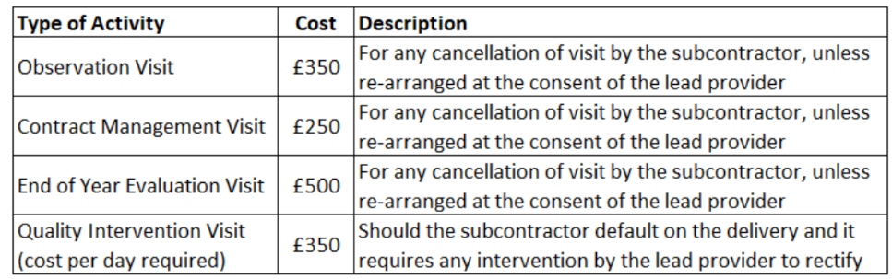

Payment
Payment to subcontractors will be made within 30 days of the invoice being received, subject to all paperwork and necessary records having been accurately submitted.

Declaration to the ESFA
In line with ESFA funding rules Cogent Skills will submit a subcontractor use declaration to the ESFA at least twice a year, summarising the value of subcontracted provision paid in the previous period. Cogent Skills will additionally publish a summary of payments made to subcontractors on its website each year.

Monitoring and Review
This policy will be reviewed after any change to statutory requirement or organisational or management change, or otherwise annually.

https://www.gov.uk/government/publications/esfa-subcontracting-standard/esfa-subcontracting-standard
https://www.gov.uk/government/publications/apprenticeships-subcontracting
https://www.gov.uk/guidance/apprenticeship-funding-rules
https://download.apprenticeships.education.gov.uk/roatp

