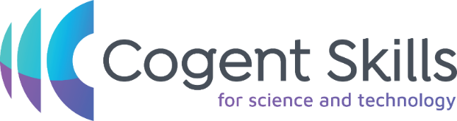
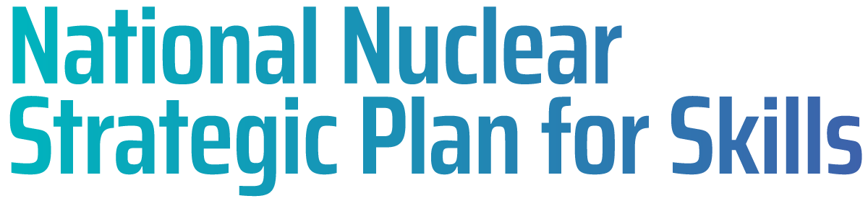

NUCLEAR SPONSORSHIP SCHEME 2025 – APPLICATION PACK

Application Stage
The application stage of the process for the Nuclear Sponsorship Scheme will be open from 11th February to 31st March 2025. If you are interested in being considered for this scheme, you will need to complete the application form on our website here – https://cogentskills.com/nuclear-industry-sponsorship/
To support you in completing this application and understand why we’re requesting certain information, please see the details below.
We will ask you to give details of your approximate household income at home, and to let us know if you have ever been in receipt of free school meals. These pieces of information are important to allow us to determine your eligibility for the scheme, given it is aimed at supporting those from lower socio-economic backgrounds. Please do be honest with these answers, as it helps us to build a better understanding of your circumstances.
The form will ask you to enter personal details such as name, home address, and contact information. This is for our internal use only and allows us to get in touch with you if we have any questions or if you go through to the next stage of the process.
We will ask some questions around your Right to Work status in the UK and any VISA’s you may require. This is again to determine eligibility for the scheme, so please be up front and honest about any Dual Nationalities you may hold, or any time spent outside of the UK. You must have also been resident in the UK for the past 5 years. If you're unsure about any questions on the form, please take the time to check with family members or others to ensure your answers are accurate before submitting. This is an important part of the process as it is checked again later down the line if successful and invited to Security Clearance. We wouldn’t want you to get to this late stage of the process and have an offer withdrawn if the information has turned out to be inaccurate.
We ask you to provide your top two university choices from your UCAS application, including the course title and university name. It will also ask you further information around the duration of the course/placement years as this scheme is only able to fund degrees up to a maximum duration of 3 years, and they cannot include a sandwich placement year. Please note that only STEM related courses will be accepted.
Information about your current/previous studies is also important to us, so we ask you to share your achieved or predicted Level 3 qualifications – whether this be A Levels, BTEC’s or similar. Proof of these qualifications will be asked from you at a later stage, and the offer will be conditional upon us certifying these.
There are a couple of questions on the form around Equality, Diversity and Inclusion – please note that these are a complete optional and you do not need to answer should you not wish to. Again, this is for our internal records and monitoring to ensure we are providing fair opportunities to all.
Finally, the application form will ask you ‘where did you find this opportunity’, and there will then be a dropdown list of multiple options. This is helpful for us to track where our applications came from, whether that be a charity or your school/college, as it enables us to drive engagement for future years.

Process
Once you have submitted your application, this will be reviewed by our Recruitment team who will determine your eligibility. You may not hear back from us immediately, so please do not worry.
If your application has been marked as eligible, it will be moved forward to the next stage of the process which will involve a one-way video interview. When you reach this stage, you will receive an email from ourselves with details of how and when to complete this, along with supporting documentation to enable you to perform at your best. It is typically a short interview, consisting of a handful of questions, just to enable us to get to know you a little bit better and understand your motivations behind applying for the scheme and a potential career in the Nuclear Industry.
Once your video interview has been completed, it will be watched and scored internally, and then a shortlist will be produced to send across to the supporting scheme employers. This will be a combination of your video interview, and the details from your application form.
Employers will then meet to discuss the shortlist and decide which students will be brought to final interview stage.
Offer
If you are successful following an interview, and offered a place on the scheme, this will be conditional on passing Security checks and any medical checks that may be required. You will be allocated to an employer and then instructed to complete security clearance with that employer. Part of the scheme involves 45 day summer placements at the end of year one and 2 of your university course. The employer taking you through security clearance may be required to update your clearance before joining the placement activity.
Security
Each employer will have a slightly different process when it comes to Security Clearance, however generally all will require the same information from yourself.
At some point during the security clearance process or before, we generally will require the below from yourself;
- A copy of your passport
- Copies of other supporting ID such as driving licence
- References to cover last 3 years, could be from education/employment
- DBS check will be required
- Individual employer security forms to be completed
It is important that once you reach offer stage of the process, that you begin to gather the above documents to enable you to be organised when it comes to us asking for these pieces of information later down the line. This will help to avoid any delays with security checks and subsequently your onboarding/tuition payments being released.
If you have any questions relating to any stage of the process detailed above, please don’t hesitate to email Chloe at chloe.barrow@cogentskills.com
The National Nuclear Strategic Plan for Skills (Nuclear Skills Plan) is an industry and government-backed plan, launched in May 2024, to address the national nuclear skills shortage. The Nuclear Skills Plan sets out targeted action to help create the nuclear workforce of the future, building on existing nuclear sector skills work and introducing new initiatives to enable us to fill an additional net 40,000 jobs the sector estimates it will need by 2030 to drive growth, ensure energy and national security, and deliver our clean energy mission.
The Nuclear Skills Plan includes fifteen projects to which prime nuclear organisations, and their government counterparts, have committed to delivering to attract and retain both new entrants and mid-career switchers and upskill the nuclear workforce.

