Ofsted Consultation- Spring 2025 Summary
During the summer of 2024, Ofsted ran the Big Listen, its most significant open consultation to gather feedback and views from all interested parties.
Following the Big Listen, they set out plans on what action they would take and introduced three core objectives to work towards:
  - to reset relationships with those Ofsted regulates and inspects, working collaboratively to put children and learners first
  - to foster a culture of integrity in which Ofsted always treats people with professionalism, courtesy, empathy and respect
  - to be a learning organisation that operates transparently, listens to challenge and takes action to change

Through the objectives they then set out further plans on how they would meet the objectives through a series of activities; as shown below:
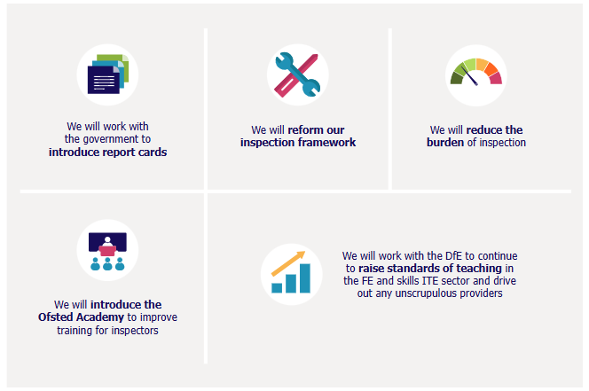
In February this year, they launched a consultation on their approach to reforming the inspection framework. The consultation is broken down into key proposals of which the first two are the most relevant for employers.

Proposal 1- Report Cards
They propose to use a 5-point scale to grade different areas of a provider’s work, such as ‘curriculum’ and ‘leadership’, with the addition of short descriptions summarising their findings. These evaluations will make up the new education inspection report cards.
For FE and skills providers the following areas will be inspected
Provider as a whole:
- leadership
- inclusion
- safeguarding

Provider as a whole, but only in colleges and specialist designated institutions:
- contribution to meeting skills needs
- For each type of provision offered (education programmes for young people, provision for learners with high needs, apprenticeships and adult learning programmes):
- curriculum
- developing teaching and training
- achievement
- participation and development

Through the report cards; the following will be looked at:
- Placing more emphasis on children and learners outcomes- not exclusively to exams but at ‘every stage of their learning journey, so that they can move confidently and smoothly into the next phase of education or training – or into employment’. Learner welfare and wellbeing will also be looked at to ensure providers are supporting students.
- How well are leaders developing their teachers; developing subject knowledge and teaching practice; including how to adapt approaches for every learner.
- Increase focus on ‘disadvantaged children and learners, those with special educational needs and/or disabilities (SEND) and those who leaders have identified as being particularly vulnerable.’

Ofsted are proposing the following scale:
Exemplary (highest quality provision) – a provider where all evaluation areas are graded as at least secure and, within an evaluation area that is consistently strong, there is a feature of practice that could be considered as exemplary
Strong – practice is consistently secure across different year groups, key stages and subjects/aspects of learning. Leaders are working above and beyond the legal and professional standards expected of them
Secure – the provider is offering a secure standard of education. This includes meeting the legal requirements and the expectations set out in non-statutory guidance, as well as the professional standards required of the particular type of provision, where applicable
Attention needed – some aspects of provision are inconsistent, limited in scope or impact and/or not fully meeting the legal requirements, the expectations set out in non-statutory guidance, or the professional standards required, where applicable. However, inspectors have determined that leaders have the capacity and means to make the necessary improvements
Causing concern (lowest quality provision) – needs urgent action to provide a suitable standard of education and/or care for children and learners

Proposal 2- Education Inspection Toolkits
Ofsted have committed to tailoring their inspection process and criteria to the education provider phase and type. This is so the inspection focuses on what really matters.
Through this work, inspection toolkits have been designed which includes the standards that inspectors will inspect during visits. ‘These standards, across a range of evaluation areas, are underpinned by statutory and non-statutory guidance, professional frameworks and expectations and research relevant to the different stages and types of education’

The toolkits describe the quality they would expect to see at each point on the scale. The toolkits are written in clear and accessible language, so that both inspectors and leaders can understand them consistently.
For FE and Skills a toolkit has been supplied as part of the consultation. This includes what inspectors would be looking for to grade the individual area. The areas that will be inspected for FE and Skills are:
- leadership
- inclusion
- safeguarding
- curriculum
- developing teaching and training
- achievement
- participation and development
- contribution to meeting skills needs (only in colleges and specialist designated institutions)

Below are two examples of what they are proposing, as well as a mock-up of the final report card:
Leadership
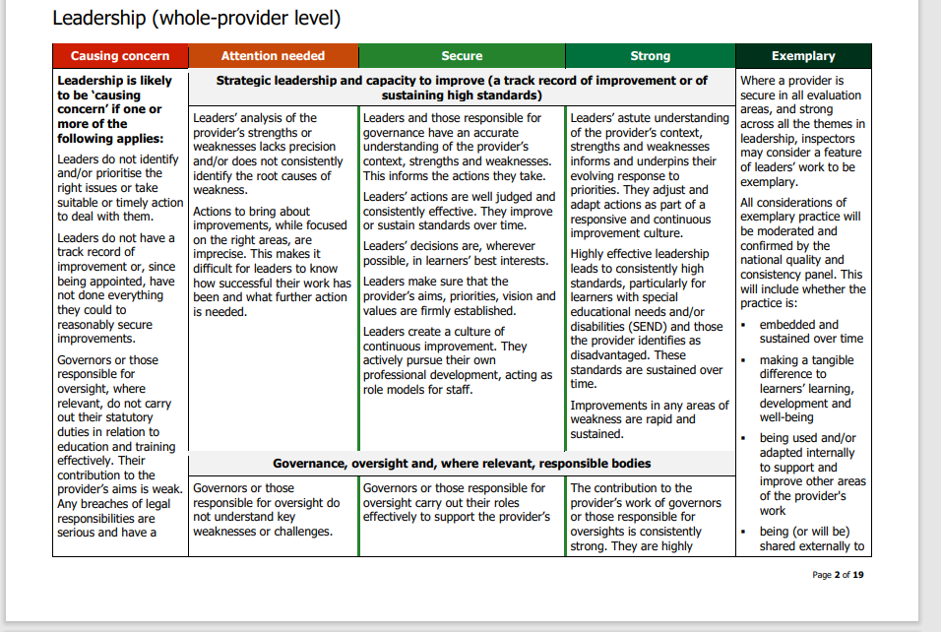

Curriculum
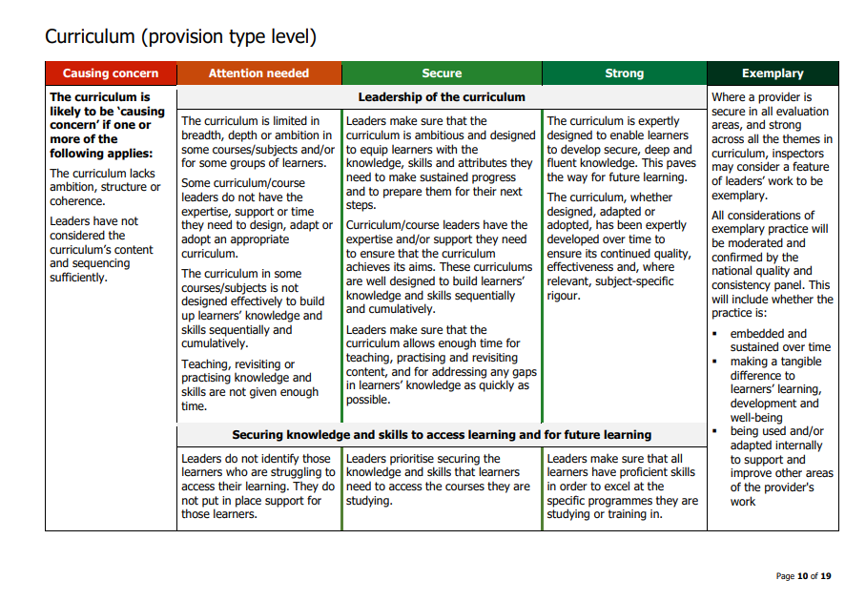
Report Card Summary (which would be published on the Ofsted Website)
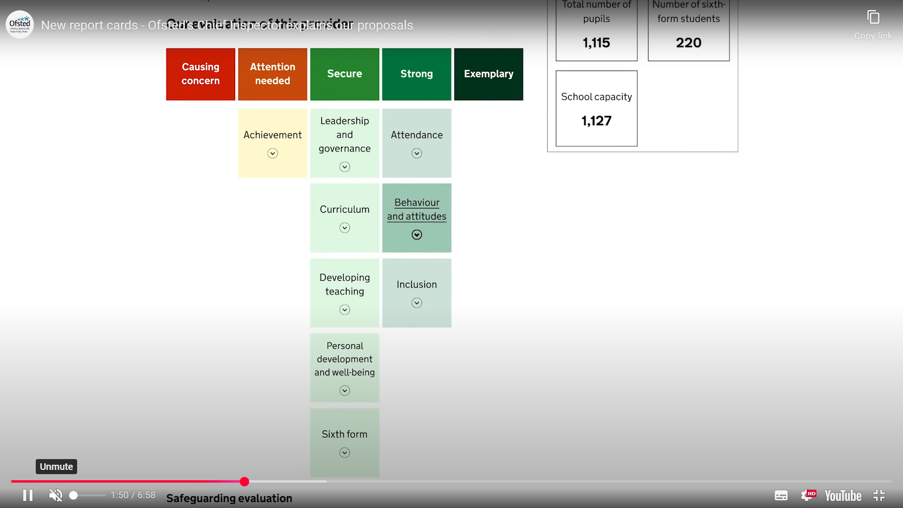

Initial Views/Thoughts
- The inclusion of ‘developing teaching and training’ is a positive move. The world is changing so quickly, and teachers need to stay competent in their knowledge base and have ongoing support to adapt teaching to individuals. Teachers must have the capacity to hone their skills as teachers but also learn new curriculum topics and new teaching methods, especially linked with advancements in technology.
- If changes are made to assessment within apprenticeships, assessment will need to be brought back into the Ofsted inspection programme. We will need to see that inspectors are not only inspecting the teaching of the curriculum but also how providers are performing formative and summative assessments if elements of independence of assessment are introduced. Employers need confidence that if providers are going to be making formal judgements on the knowledge, skills and behaviours of individuals, they have the correct processes and procedures to enable this.
- There are fears that despite Ofsted saying this new way of inspecting will ease the pressure, inspectors are making more judgements, so more preparation will be needed—teachers should be teaching!
- Despite the introduction of toolkits to support different provision types, the feeling remains that inspections are more geared towards FE colleges rather than universities and independent training providers. We encourage universities who are delivering apprenticeships and ITPs who we know deliver the majority of apprenticeships to share their views to ensure they can work with the new framework.

Cogent will not be making a submission to the current consultation but will continue to update employers and stakeholders on the progress being made and will support employers with the transition to the new framework and their impacts in the summer/autumn.
If anyone has any questions or wants to understand more- please contact Rachel Roby.
To read the consultation documentation in full click here

